1. Excel File for this exercise: <https://drive.google.com/file/d/1H8hsXayk-Gf2cng1BZk5AIDRf3eU2Wrw/view?usp=sharing>

**Question:**

Create 3 new rows with UPPER, LOWER, and PROPER from the Tutor column

**Answer:**

1. In a new column: type =UPPER(H2)

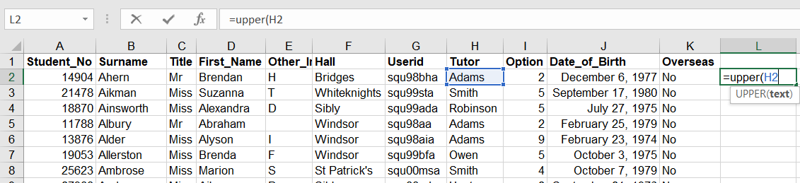

1. <press Enter> and drag the box till last row

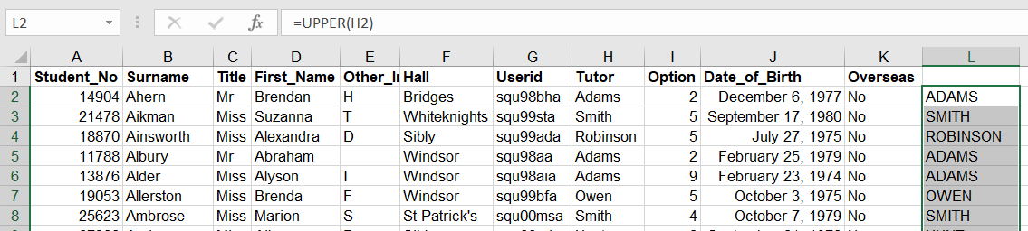

1. In a new column: type =LOWER(L2)

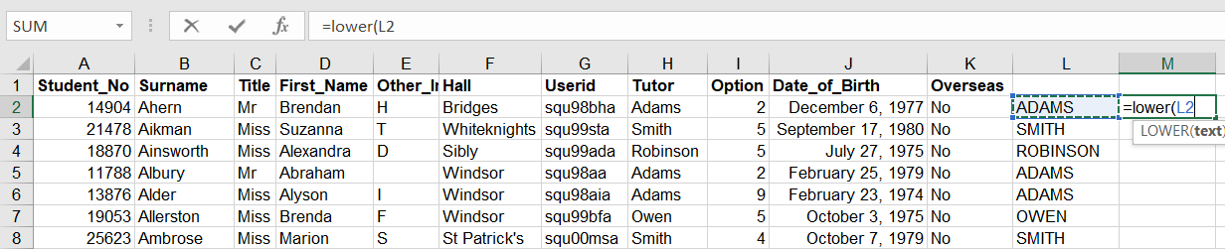

1. <press Enter> and drag the box till last row

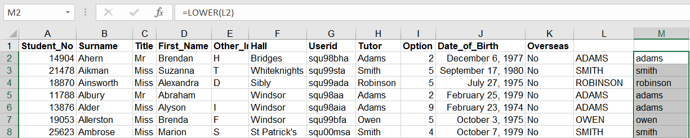

1. In the new column: type =PROPER(M2)

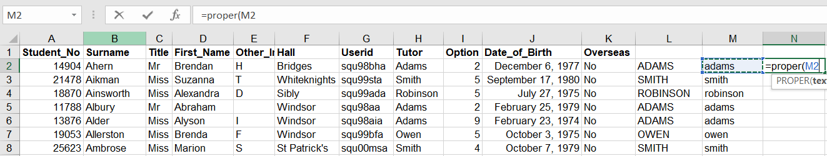

1. <press Enter> and drag the box till last row

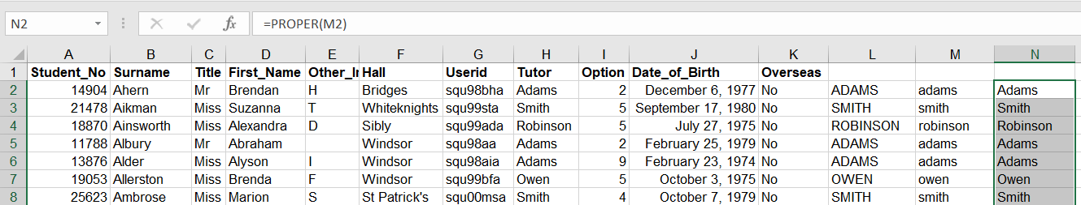

1. **Data :** <https://drive.google.com/file/d/1Gzm2Kq2l3Z0E8T6NkLhPCMO-0caHTIu0/view?usp=sharing>

**Question:**

From the given customer data customer’s address column has zip code and customer’s phone number in it. You have to create separate columns for phone number and zip code.

**Answer:**

1. In a Zip column: type =Left(B2, 6)

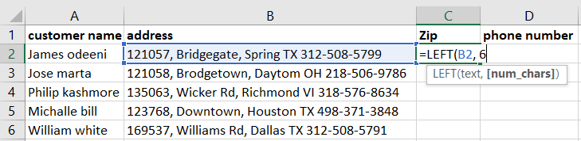

1. <press Enter> and drag the box till last row

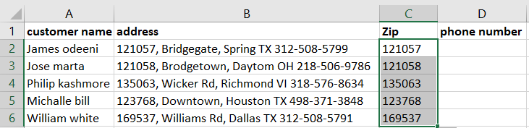

1. In a phone number column: type =right(B2, 12)

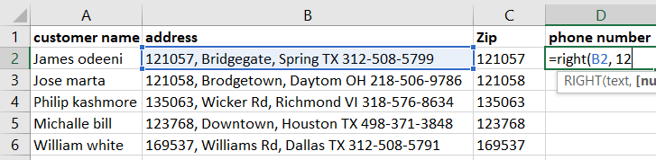

1. <press Enter> and drag the box till last row

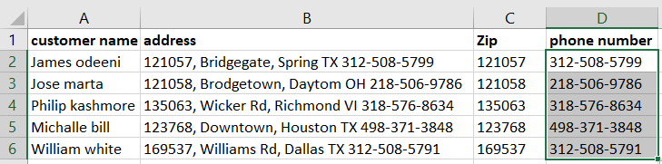

Download the data from this link: <https://drive.google.com/file/d/1Q1cjykHVRNLMayG1d8I8SkWcK0CIhVmB/view?usp=sharing>

**Question:** In the given data, Investors first, middle and last name are in same column. Create separate columns for first and last names using Left, Right, find functions

**Answer:**

1. In a First Name column: type =left(A2,find(“ “,A2-1)

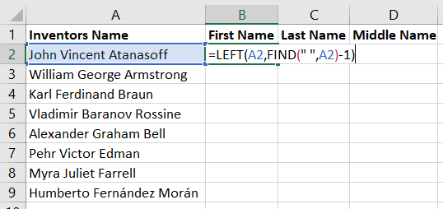

1. <press Enter> and drag the box till last row

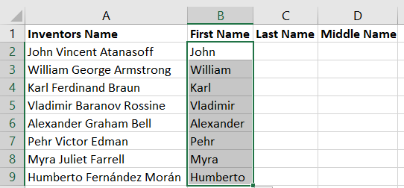

1. **In the Last Name column:** =RIGHT(MID(A2,FIND(" ",A2)+1,LEN(A2)),LEN(MID(A2,FIND(" ",A2)+1,LEN(A2)))-FIND(" ",MID(A2,FIND(" ",A2)+1,LEN(A2))))

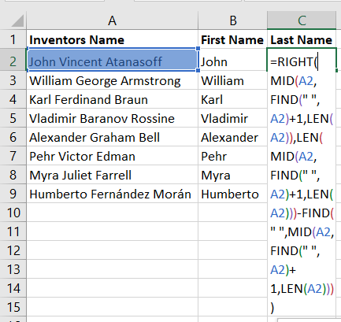

1. **<press Enter> and drag till last row**

